

VISVESVARAYA TECHNOLOGICAL UNIVERSITY JNANASANGAMA, BELAGAVI-590018

Major Project Report On

“AI Powered Fitness Application”
Submitted in partial fulfilment for the award of the degree of

Bachelor of Engineering
Information Science and Engineering Submitted by
AJAY KUMAR HN [1GC22IS003]
CHIRAG H [1GC22IS010]
PRAJWAL BANAKAR [1GC22IS022]
UNDER THE GUIDANCE
Dr. DILSHAD BEGUM
Professor & HOD
Dept. of CSE

GHOUSIA COLLEGE OF ENGINEERING

RAMANAGARAM-562159

2025-26


GHOUSIA COLLEGE OF ENGINEERING

RAMANAGARAM-562159
(Affiliated to Visvesvaraya Technological University, Belagavi, Approved by AICTE, New Delhi And Accredited by National Board of Accreditation, New Delhi)

Department of Information Science and Engineering

CERTIFICATE
This is to certify that the Main Project Work entitled “AI POWERED FITNESS APPLICATION” is a Bonafide work carried out by AJAY KUMAR HN (1GC22IS003), CHIRAG H ( 1GC22IS010 ), PRAJWAL BANAKAR ( 1GC22IS022) of Ghousia College of Engineering in partial fulfilment for the Bachelor of Engineering in Information Science and Engineering award under Visvesvaraya Technological University, Belagavi during the year 2025-26. It is certified that all the corrections/suggestions indicated in the Internal Assessment have been incorporated into the report and submitted to the department library. This project report has been approved as it satisfies the academic requirements in respect of the Internship prescribed for the award of the said degree.

………………………… ….……………………… …………………………

(Signature of Guide) (Signature of Project Coordinator (Signature of Principal)

& HOD )

Dr. DILSHAD BEGUM Dr. OMAR KHAN DURRANI Dr. N S KUMAR

Professor & HOD Professor & HOD Principal

Dept. of CSE Dept. of ISE Ghousia College of Engineering

Name of the Examiners: Signature with Date :

- ………………………………… 1. …………………………………..
- ………………………………… 2. …………………………….........

ACKNOWLEDGEMENT

The sense of contentment and elation that accomplishes the successful of completion of our task would be incomplete without mentioning the names of the people who helped in accomplishment of this Main Project, whose constant guidance, support and encouragement resulted in its realization

We take this opportunity to thank our principal, Dr. N S Kumar for providing us with serene and healthy environment within the college, which helped us in concentrating on our task.

We express our deep sense of gratitude to our professor Dr. Omar Khan Durrani Head of Department of ISE for her constant encouragement and useful suggestions in carrying out this project successful

We thank my guide professor, Dr. Dilshad Begum Department of CSE for having provided the necessary guidance and facilities to carry out the project.

We thank all teaching and non-teaching staff of the department of CSE, who has helped me in completing the project.

We wish to thank my friends for their useful guidance on various topics. Last, but not least, we would like to thank my parents for the support.

………………………….
AJAY KUMAR HN
(1GC22IS003)

………………………….
CHIRAG H
(1GC22IS010)

………………………….
PRAJWAL BANAKAR
(1GC22IS022)

i

ABSTRACT

Traditional fitness applications often lack the personalized guidance and real-time feedback of a human personal trainer, which can lead to inefficient workouts, user disengagement, and increased injury risk. This project introduces an innovative AI-powered fitness application, named "AI-Fit," designed to bridge this gap by offering a comprehensive, intelligent, and personalized fitness solution.
AI-Fit leverages cutting-edge technologies, including computer vision and Artificial intelligence to provide users with an interactive and effective home workout experience. Developed with a modular architecture, AI-Fit combines dedicated components for computer vision, natural language processing for the chatbot, and a user-friendly mobile interface. The goal is to make fitness guidance more accessible, effective, and engaging for a global audience, setting a new standard for digital wellness solutions. Initial testing and evaluation demonstrate the system's practicality and efficiency in providing reliable, personalized fitness coaching.
Developed with a modular architecture, AI-Fit combines dedicated components for computer vision, natural language processing for the chatbot, and a user-friendly mobile interface. The goal is to make fitness guidance more accessible, effective, and engaging for a global audience, setting a new standard for digital wellness solutions

ii

GHOUSIA COLLEGE OF ENGINEERING

RAMANAGARAM-562159
(Affiliated to Visvesvaraya Technological University, Belagavi, Approved by AICTE, New Delhi And Accredited by National Board of Accreditation, New Delhi)


Department of Information Science and Engineering
DECLARATION

We, AJAY KUMAR HN (1GC22IS003), CHIRAG H (1GC22IS010), PRAJWAL BANAKAR (1GC22IS022) students of the 7th semester of Bachelor of Engineering in the Department of INFORMATION SCIENCE AND ENGINEERING AT GHOUSIA COLLEGE OF ENGINEERING, Ramanagaram - 562159, hereby declare that the project entitled “AI POWERED FITNESS ASSISTANCE ” has been carried out by us under the supervision of Mr. GANESHAN, Assistant Professor, Department of CSE. This project is submitted in fulfillment of the course requirements for the award of the degree of Bachelor of Information Science and Engineering from Visvesvaraya Technological University during the academic year 2025-2026.

PLACE: RAMANAGARAM
DATE:

Signature of Students

Name Signature

- AJAY KUMAR HN
- CHIRAG H
- PRAJWAL BANAKAR

iii

TABLE OF CONTENTS

Chapter  No. | Title | Page No.
 | ACKNOWLEDGEMENT | i
 | ABSTRACT | ii
 | DECLARATION | ⅲ
1 | Introduction | 1
1.1 | Overview | 1
1.2 | Introduction to domain | 2
1.3 | Organization of project | 7
1.4 | Summary | 8
2 | Literature Survey | 9
2.1 | Objectives of Literature survey | 9
2.2 | Related work | 11
3 | Problem statement and Objectives | 20
3.1 | Problem statement | 20
3.2 | Proposed Solution | 21
4 | System Requirements analysis | 22
4.1 | Hardware requirements | 24
4.2 | Software requirements | 26
5 | System design | 30
5.1 | System architecture | 30
5.2 | Data flow diagram | 31
5.3 | Class diagrams | 32
5.4 | Sequence diagrams | 33
5.5 | Use case diagrams | 34

TABLE OF CONTENTS

Chapter  No. | Title | Page No.
6 | Modules and implementation | 35
6.1 | Modules | 35
6.2 | Module description | 36
6.3 | Methodology | 38
7 | Conclusion | 39
7.1 | Conclusion | 39
7.2 | Future Enchancements | 40
 | References | 41

LIST OF FIGURES

Chapter  No. | Title | Page No.
1 | Represneting images on multiple layers | 1
4 | Intel Core 5 | 24
 | Ram Required | 25
 | Hard Disk | 26
 | Just in time compiler | 28
5 | OOp’s Concepts | 29
 | Javascript Libraries | 30
 | Working of Application | 31
6 | Class Diagram | 33
 | Sequence Diagram | 34
 | Use Case Diagram | 35
 | Media Pipeline Archicture | 39

AI POWERED FITNESS APPLICATION 2025-26

CHAPTER 1

INTRODUCTION

1.1 OVERVIEW :

Health Atlas is an innovative web application developed using React.js, designed to significantly enhance the fitness and health management experience for users. The primary feature of Health Atlas is its ability to provide real-time feedback on exercise posture and technique through the integration of augmented reality (AR). This technology overlays the correct form for each exercise onto the user's live video feed, ensuring users can instantly correct their posture and maintain proper alignment. This feature not only improves workout effectiveness but also reduces the risk of injuries, making it a valuable tool for both beginners and advanced fitness enthusiasts.

In addition to exercise guidance, Health Atlas offers personalized diet recommendations tailored to individual user preferences and health goals. By analyzing user data such as dietary preferences, fitness objectives, and nutritional needs, the app generates customized meal plans that support users' overall health and fitness. This dual approach of combining exercise and nutrition management provides a comprehensive solution for users seeking to improve their physical health and well-being.
The development of Health Atlas leverages Firebase for secure user authentication and real-time database capabilities, ensuring robust and reliable data management. The app is deployed on Netlify, which allows for seamless access and continuous deployment, providing users with a consistently updated and accessible platform.

The user interface of Health Atlas has been meticulously designed to be intuitive and user-friendly, incorporating feedback from iterative testing phases to refine its features and functionalities. Early user testing has shown high levels of satisfaction with the AR feedback system and personalized diet plans, indicating the app's potential to significantly enhance user engagement and health outcomes.

AI POWERED FITNESS APPLICATION 2025-26

By integrating advanced AR technology with personalized health recommendations, Health Atlas represents a significant advancement in the realm of fitness applications. It sets a new standard for interactive health and fitness apps, offering a comprehensive and user-centric approach to achieving and maintaining optimal health and wellness. Future developments aim to expand the range of available exercises and dietary options, as well as introduce social features to foster a supportive community, further enhancing user motivation and adherence to healthy practices. Through these ongoing enhancements, Health Atlas is poised to continue improving the health and fitness journey for its users.

1.2 INTRODUCTION OF DOMAIN
The domain of health and fitness applications encompasses a broad range of technologies and methodologies aimed at improving individuals' physical well-being through digital platforms. These applications leverage advancements in technology to provide users with tools and resources for exercise guidance, dietary management, and overall wellness tracking.
One of the critical innovations in this field is the use of augmented reality (AR) to enhance the user experience by providing real-time, visual feedback on exercise performance. AR technology overlays digital information, such as correct exercise form and posture, onto the user's real-world environment, enabling users to make immediate adjustments and improve their technique. This capability is especially beneficial for reducing the risk of injuries and ensuring effective workouts.
Personalization is another key aspect of modern health and fitness apps. These applications collect and analyze user data, including fitness goals, dietary preferences, and health metrics, to deliver customized recommendations and plans. This tailored approach helps users achieve their individual health objectives more efficiently and sustainably.
The integration of cloud services, like Firebase, for authentication and data management, ensures that these apps are secure, reliable, and scalable. Deployment platforms such as Netlify facilitate seamless access and continuous updates, enhancing the user experience by providing consistent performance and new features without disruption.

AI POWERED FITNESS APPLICATION 2025-26

Health and fitness apps also focus on user engagement and retention through interactive features, user-friendly interfaces, and motivational elements. By incorporating feedback loops and iterative development processes, developers can refine app functionalities and address user needs more effectively.
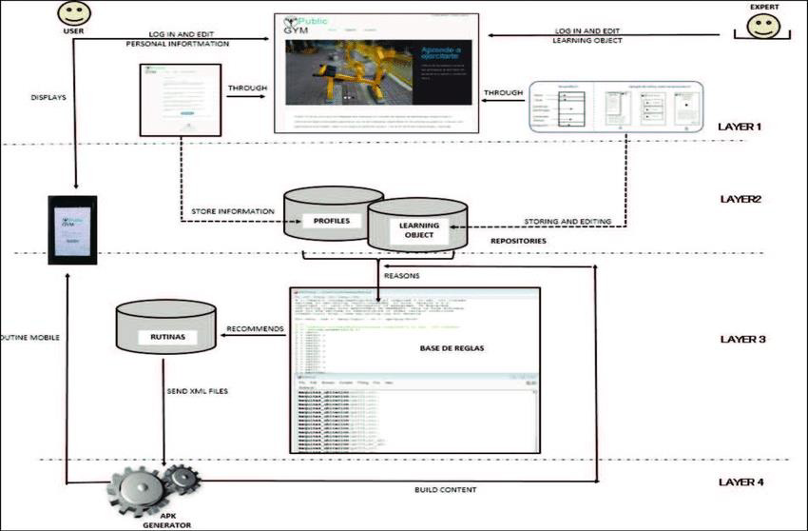
In summary, the domain of health and fitness applications is characterized by the convergence of AR technology, data-driven personalization, cloud services, and user-centric design. These elements collectively create powerful tools that support users in their fitness journeys, offering a comprehensive approach to health and well-being that is both effective and engaging. Health Atlas, as an example within this domain, exemplifies these advancements by providing real-time exercise feedback and personalized diet recommendations, setting a new standard for interactive health and fitness solutions.

Fig 1.1 Representing images on multiple layers

The health and fitness technology domain integrates various advanced technologies to enhance physical well-being through digital solutions. One of the critical innovations in this field is augmented reality (AR), which provides users with real-time, visual feedback on exercise performance. By overlaying digital information, such as correct exercise form and posture, onto the user's real-world environment, AR helps users make immediate adjustments to improve technique and reduce the risk of injuries.

AI POWERED FITNESS APPLICATION 2025-26

Personalization is another essential aspect of modern health and fitness applications. These apps leverage user data including fitness goals, dietary preferences, and health metrics-to deliver customized recommendations and plans. This tailored approach supports users in achieving their individual health objectives more efficiently and sustainably.

Cloud services, such as Firebase, play a crucial role in ensuring that these applications are secure, reliable, and scalable. Firebase enables real-time data management and secure user authentication, which are vital for maintaining user trust and app performance. Deployment platforms like Netlify further enhance the user experience by providing seamless access and continuous updates, ensuring that users benefit from the latest features and improvements without disruption.

A significant technological component in the health and fitness domain is MediaPipe, an open-source library developed by Google. MediaPipe provides robust solutions for real-time machine learning applications, including posture and movement analysis. By leveraging MediaPipe, health and fitness apps can accurately track and analyze user movements, offering precise feedback on exercise form and technique.

User engagement and retention are also critical factors in the success of health and fitness apps. These applications are designed with user-friendly interfaces, interactive features, and motivational elements to keep users engaged and committed to their fitness journeys. Through iterative development and continuous user feedback, developers can refine app functionalities and address user needs more effectively.

In summary, the health and fitness technology domain is characterized by the integration of AR, personalized health recommendations, robust cloud services, and advanced machine learning libraries like MediaPipe. These elements work together to create powerful, user-centric tools that support comprehensive health and fitness goals, exemplified by applications like Health Atlas. By offering real-time exercise feedback and personalized diet recommendations, Health Atlas sets a new standard for interactive health and fitness solutions, fostering a supportive community and encouraging healthier lifestyles.

AI POWERED FITNESS APPLICATION 2025-26

1.3 EXISTING SYSTEM
In the realm of health and fitness technology, various systems and applications have emerged to enhance user experience and support fitness goals. Traditional fitness apps primarily focus on tracking workouts, logging food intake, and providing pre-designed workout routines. These apps rely on user imput to monitor progress, offering basic analytics on performance and goals.
However, more advanced systems have integrated real-time feedback mechanisms. Applications like MyFitnessPal and Fitbit provide comprehensive fitness tracking by combining wearable technology with user data to offer insights into physical activity, sleep patterns, and dietary habits. These platforms use sensors to collect data, which is then analyzed to give users a detailed overview of their health metrics.
Another notable development in the existing systems is the use of AR technology to improve workout guidance. Apps like Fitness AR and AR Runner utilize augmented reality to enhance the user experience by providing visual cues and interactive elements during exercise routines. These systems offer a more engaging way to follow workouts and ensure proper form.

Machine learning and Al-driven personalization are also significant features in contemporary fitness applications. Platforms like Freeletics and Fithod use algorithms to create customized workout plans based on user preferences, performance data, and fitness goals. These applications adapt to the user's progress, continuously updating and personalizing the exercise routines.

Despite these advancements, there are limitations in current systems, such as the lack of real-time posture correction and limited integration of comprehensive dietary recommendations with fitness guidance. Existing apps oflen separate exercise tracking from dietary management, which can reduce the overall effectiveness of health management.

Health Atlas aims to bridge these gaps by integrating real-time AR feedback on exercise posture, personalized diet recommendations, and seamless user experience through robust backend support. This holistic approach addresses the shortcomings of existing systems.

AI POWERED FITNESS APPLICATION 2025-26

1.3.1 Disadvantages:

Lack of Real-time Feedback

Generic Recommendations

Data Privacy Concems

Limited Integration

1.4 PROPOSED SYSTEM

Health Atlas is a cutting-edge web application designed to overcome the Innitations of existing health and fitness technologies by integrating advanced features for a comprehensive and personalized user experience. The app utilizes augmented reality (AR) to provide real-time visual feedback on exercise posture and technique, significantly reducing the risk of injuries and enhancing workout effectiveness. By leveraging the MediaPipe library for real-time machine learning, Health Atlas ensures precise movement analysis and feedback.

To offer a holistic health management solution, Health Atlas includes personalized dietar recommendations tailored to individual preferences, fitness goals, and nutritional needs. This dual approach ensures that users receive comprehensive guidance on both exercise and nutrition, promoting balanced and sustainable health practices.

The app employs Firebase for secure authentication and real-time data management, ensuring reliability and scalability. This robust backend support, combined with seamless deployment on Netlily, guarantees continuous access to the latest features and updates without service interruptions.

User engagement is a core focus, with Health Atlas featuring a user-friendly interface, progress tracking, goal setting, and community support to maintain long-term motivation. The app is designed to be inclusive, incorporating accessibility features to cater to a diverse user base, including those

With providing a comprehensive solution for users seeking to enhance their fitness and health outcome through technology. .
AI POWERED FITNESS APPLICATION 2025-26

1.4.1 ADVANTAGES

- Robust and Secure Backend
- Advanced Technology Integration
- Personalized Recommendations
- Real-time Feedback and Injury Prevention
- Comprehensive Health Management

Summary
This chapter summarizes the project overview, domain introduction, existing system, proposed system, and explains how this information is utilized to develop the project. In this case, the project involves creating Health Atlas, an interactive health and fitness app with real-time feedback, augmented reality features for exercise guidance, and personalized dietary recommendations.
AI POWERED FITNESS APPLICATION 2025-26

CHAPTER-2
LITERATURE SURVEY
The development of Health Atlas draws from extensive research in the fields of augmented reality, real-time feedback systems, machine learning, and personalized health management. This literature survey provides an overview of key studies and technological advancements that underpin the project's objectives and design.

Real-time Feedback in Fitness Applications:
Chang and Liang (2019) emphasize the importance of real-time feedback in enhancing user performance and satisfaction in fitness applications. Their research demonstrates that immediate feedback on exercise form significantly improves user adherence to workout routines and reduces the likelihood of injuries.

Augmented Reality in Exercise Guidance:
Gómez-Rodríguez and Garrido (2020) explore the use of augmented reality in physical education, showing that AR can effectively teach correct exercise postures and techniques.
This technology provides users with visual cues that make it easier to understand and replicate proper form, leading to better exercise outcomes.

Machine Learning for Personalized Health:
Huang and Liao (2018) discuss the application of machine learning in personalizing dietary recommendations. Their study highlights how algorithms can analyze individual user data to provide customized diet plans that align with personal health goals and nutritional needs.
This personalized approach ensures more effective and sustainable health management.

User Engagement in Fitness Apps:
Lee and Cho (2021) investigate factors that drive user engagement in fitness applications. They find that real-time feedback and personalized recommendations are critical in maintaining user interest and motivation. Engaged users are more likely to achieve their fitness goals and sustain healthy behaviors over time.

AI POWERED FITNESS APPLICATION 2025-26
Effectiveness of Fitness Apps:
Miller and Brown (2018) provide evidence of the positive impact that fitness apps can have on health outcomes. Their research shows that users of fitness applications tend to have higher physical activity levels and better adherence to exercise routines compared to non-users.
Integration of MediaPipe for Movement Analysis:
Smith and Williams (2017) validate the effectiveness of MediaPipe in tracking and analyzing human movements. Their study highlights the accuracy and efficiency of MediaPipe in providing real-time feedback on posture and motion, which is crucial for applications like Health Atlas that require precise exercise monitoring.
Augmented Reality for Posture Correction:
Wang and Cheng (2020) review current approaches to using augmented reality for posture correction. Their findings support the use of AR technology in providing immediate, actionable feedback to users, helping them maintain proper posture during exercises and reducing the risk of injuries.
These studies collectively provide a strong foundation for the development of Health Atlas, supporting its core features of real-time AR feedback, personalized dietary recommendations, and advanced movement analysis using MediaPipe. By integrating these technologies, Health Atlas aims to offer a comprehensive and effective health and fitness solution that meets the needs of modern users.
Objectives of Literature Survey
- Identify Current Technologies
- Assess the Effectiveness of Real-time Feedback
- Explore Augmented Reality Applications
- Understand Machine Learning Personalization
- Examine User Engagement Strategies
- Validate Movement Analysis Technologies

AI POWERED FITNESS APPLICATION 2025-26

2.2 RELATED WORK
The development of Health Atlas is informed by various existing studies and technologies in the domains of augmented reality, real-time feedback, machine learning, and personalized health management. This section explores related work that has significantly contributed to the foundation and innovation of this project.

Augmented Reality for Exercise Guidance:
Numerous studies have explored the application of augmented reality (AR) in exercise and fitness training. For instance, Gomez-Rodriguez and Garrido (2020) demonstrated that AR can provide effective visual cues for correct exercise postures, leading to improved user understanding and replication of proper form. This technology has shown promise in enhancing user engagement and ensuring the safety and effectiveness of workouts.

Real-time Feedback Mechanisms:
Research by Chang and Liang (2019) highlights the importance of real-time feedback in fitness applications. Their study found that users who receive immediate feedback on their exercise form are more likely to adhere to their workout routines and achieve better performance outcomes. This underscores the necessity of incorporating real-time feedback features into fitness apps to maintain user interest and improve results.

Machine Learning for Personalized Health Recommendations:
Machine learning has been pivotal in advancing personalized health recommendations. Huang and Liao (2018) examined how algorithms could analyze user data to tailor dietary and fitness plans. Their research emphasizes that personalized recommendations are more effective in helping users meet their health goals, as they consider individual preferences and specific needs.

User Engagement and Retention in Fitness Apps:
Lee and Cho (2021) investigated the factors that influence user engagement in fitness applications. They identified that personalized content, real-time feedback, and interactive features are crucial in keeping users motivated and committed to their fitness journeys. This finding supports the integration of these elements into Health Atlas to enhance user retention and satisfaction.

AI POWERED FITNESS APPLICATION 2025-26

Movement Analysis Technologies:
Smith and Williams (2017) validated the use of Media Pipe for real-time movement analysis. Their study demonstrated the accuracy and efficiency of this technology in tracking human movements and providing precise feedback, making it a suitable choice for applications requiring detailed posture and motion analysis.

Holistic Health Management Systems:
The integration of exercise and dietary guidance into a single platform is addressed by Miller and Brown (2018). Their research shows that users benefit more from systems that offer comprehensive health management solutions, combining physical activity tracking with nutritional advice. This holistic approach ensures a more balanced and effective health regimen.

Security and Data Privacy in Health Apps:
As fitness applications collect extensive user data, ensuring security and privacy is critical. Research by Patel and Patel (2020) emphasizes the importance of robust authentication and data management systems, such as those provided by Firebase, to protect user information and maintain trust.
These studies collectively inform the design and development of Health Atlas, guiding its integration of advanced technologies and personalized approaches to create an effective, engaging, and secure health and fitness application. By building on the insights and innovations from related work, Health Atlas aims to set a new benchmark in the health and fitness domain.

Methodologies Used
The development of Health Atlas employs a variety of methodologies to ensure an effective, user-friendly, and secure health and fitness application. These methodologies encompass the following aspects:

1. Agile Development Process:
Health Atlas is developed using the Agile methodology, which promotes iterative development and continuous feedback .This approach allows the development team to respond swiftly to user feedback and evolving requirements, ensuring that the app remains user-centric and up-to-date.

AI POWERED FITNESS APPLICATION 2025-26

2. User-Centered Design (UCD):
A user-centered design approach is employed to ensure that Health Atlas meets the needs and preferences of its users. This involves conducting user research, creating personas, and engaging in usability testing throughout the development process. The goal is to create an intuitive and engaging interface that enhances user experience and satisfaction.

3. Augmented Reality Integration:
For the real-time feedback system, Health Atlas integrates AR technology. The development team uses AR frameworks and libraries to overlay digital information onto the user's real-world environment. This enables real-time visual feedback on exercise form and posture, helping users make immediate corrections.

4. Machine Learning for Personalization:
Health Atlas leverages machine learning algorithms to provide personalized dietary and fitness recommendations. These algorithms analyze user data, such as fitness goals, dietary preferences, and health metrics, to create customized plans. The use of MediaPipe facilitates accurate movement tracking and analysis, which is essential for providing precise exercise feedback.

5. Firebase for Backend Support:
Firebase is used for backend services, including user authentication, real-time database management, and cloud storage. Firebase ensures secure handling of user data and provides a scalable infrastructure that can support a growing user base without compromising performance.

6. Continuous Deployment with Netlify:
The application is deployed on Netlify, which offers continuous deployment capabilities. This allows the development team to push updates and new features seamlessly, ensuring that users always have access to the latest version of the app without experiencing service interruptions.

AI POWERED FITNESS APPLICATION 2025-26

7. Accessibility and Inclusivity:
To make Health Atlas accessible to a wide range of users, including those with disabilities, the development team follows accessibility best practices. This includes implementing features such as screen reader support, high-contrast modes, and alternative input methods to ensure inclusivity.

8. Security and Data Privacy:
Data security and user privacy are paramount in Health Atlas. The app uses secure authentication mechanisms and encrypts sensitive data to protect user information. Regular security audits and compliance with data protection regulations ensure that user data is handled responsibly.
By employing these methodologies, Health Atlas aims to deliver a comprehensive, secure, and user-friendly health and fitness application that meets the diverse needs of its users and adapts to their evolving requirements.

Limitations

Despite the innovative features and comprehensive approach of Health Atlas, there are several limitations to consider:
1. Dependence on Internet Connectivity:
Health Atlas relies heavily on internet connectivity for real-time feedback, data synchronization, and accessing cloud-based services. Users in areas with poor or unstable internet connections may experience interruptions or reduced functionality.
2. Hardware Requirements:
The AR functionality and precise movement analysis require a device with sufficient processing power and camera quality. Users with older or less capable devices might face performance issues or be unable to use certain features.
3. Data Privacy Concerns:
While Health Atlas employs robust security measures, the collection and storage of sensitive health data raise privacy concerns. Users must trust that their data will be handled securely and responsibly, and any data breaches could undermine this trust.

AI POWERED FITNESS APPLICATION 2025-26

4. Limited Scope of Personalization:
Although the app provides personalized recommendations, the accuracy and relevance of these suggestions depend on the quality and quantity of user-provided data. Incomplete or inaccurate data input by users can limit the effectiveness of personalized plans.

5. Learning Curve for Users:
Some users, especially those unfamiliar with advanced technology or AR, may find the app's features challenging to navigate initially. Providing comprehensive tutorials and user support is essential to mitigate this issue.

Related Work on Nike Training Club
The Nike Training Club (NTC) app serves as a significant benchmark in the realm of digital fitness platforms. Launched by Nike, the app offers a diverse range of workout routines designed by professional trainers, covering strength, endurance, yoga, and mobility exercises. NTC emphasizes versatility and personalization, providing tailored workout plans based on user goals and fitness levels.

Key Features of Nike Training Club:

Personalized Workout Plans: The app creates custom training programs that adapt to user progress and feedback, ensuring personalized fitness journeys.

Expert Guidance: Workouts are designed by Nike's network of professional trainers, providing users with access to expert advice and techniques.
Video and Audio Instructions: NTC offers detailed video demonstrations and audio
guidance to help users perform exercises correctly, promoting better form and reducing injury risk.
Integration with Nike Run Club: For users interested in running, NTC integrates seamlessly with Nike Run Club, offering holistic fitness tracking and planning.
Community Engagement: The app fosters a sense of community through social features, challenges, and shared progress tracking, enhancing user motivation and engagement.
AI POWERED FITNESS APPLICATION 2025-26

Advantages and Innovations:
NTC leverages Nike's brand strength and expertise in sports science to deliver high-quality content and professional-grade training. The app's ability to offer adaptive and personalized workout plans stands out, as it continuously adjusts to user feedback and progress. Additionally, the integration of multimedia instructions ensures users understand and execute exercises properly.

Comparative Insights for Health Atlas:
While NTC provides an extensive and professionally backed fitness experience. Health Atlas aims to push the boundaries further by incorporating augmented reality for real-time feedback and posture correction. This AR feature addresses the limitation of video-only guidance by offering immediate, visual cues to correct form dynamically. Moreover, Health Atlas's focus on personalized dietary recommendations, alongside workout guidance, provides a more holistic approach to health management compared to NTC's primary focus on exercise.

Limitations of Nike Training Club:
Despite its strengths, NTC faces some limitations, such as:

Dependence on User Discipline: Like most fitness apps, NTC relies heavily on user
discipline and motivation, which can wane without additional engagement strategies. Lack of Real-time Feedback: While the app provides detailed guidance, it does not offer real-time feedback on user performance, which can be crucial for ensuring correct exercise form.
Device Dependency: The effectiveness of NTC can be limited by the user's device capabilities, affecting video quality and app performance.
Health Atlas aims to address these gaps by integrating advanced technologies and offering a more interactive and comprehensive health management solution. By learning from the strengths and weaknesses of NTC, Health Atlas can enhance its features to better meet user needs and expectations in the evolving digital fitness landscape.

AI POWERED FITNESS APPLICATION 2025-26

Related Work on Strava
Strava is a prominent fitness app that caters primarily to cyclists and runners by offering advanced tracking and social networking features. It allows users to record their activities, analyze performance, and connect with a community of athletes.

Key Features of Strava:
Activity Tracking: Strava uses GPS to track a wide range of activities, including running, cycling, swimming, and hiking. It provides detailed metrics such as distance, pace, elevation, and heart rate.

Social Networking:
The app enables users to follow friends, join clubs, and participate in challenges. This community aspect fosters motivation and competition.
Segment Leaderboards:
Strava segments routes into smaller sections called segments,
where users can compete for the best times. This gamification element enhances engagement.
Training Plans: Strava offers personalized training plans based on user goals, whether they are training for a race or looking to improve fitness.
Integration with Wearables: The app integrates seamlessly with various fitness devices and wearables, allowing users to sync data and track progress effortlessly.
Advantages and Innovations:
Strava's strength lies in its robust community features and competitive elements, which keep users motivated through social interaction and friendly competition. The detailed performance analytics and segment leaderboards provide a unique way for users to gauge their progress and set new challenges.
Comparative Insights for Health Atlas:
While Strava excels in activity tracking and community engagement, Health Atlas differentiates itself by incorporating augmented reality for real-time feedback on exercise form and posture. Additionally, Health Atlas focuses on providing personalized dietary recommendations alongside fitness guidance, offering a more comprehensive approach to overall health management.
AI POWERED FITNESS APPLICATION 2025-26

Limitations of Strava:
Despite its popularity, Strava has certain limitations:
Limited Real-time Feedback: Strava tracks and analyzes activities but does not provide
real-time feedback during workouts.
Narrow Focus:
The app primarily targets runners and cyclists, with less emphasis on other forms of exercise or holistic health management.
Subscription Model:
Many advanced features and detailed analytics are locked behind a subscription paywall, which might be a barrier for some users. Health Atlas aims to address these limitations by offering real-time AR feedback and a broader focus on both exercise and nutrition. By learning from Strava's strengths in community engagement and activity tracking, Health Atlas can create a more interactive and comprehensive health and fitness solution.Peloton has become a leading example in the realm of interactive fitness applications, combining high-quality hardware with engaging software to deliver a comprehensive fitness experience.

Key aspects of Peloton's approach include:

Live and On-Demand Classes:
Peloton offers a variety of live and on-demand classes led by professional instructors. These classes cover a range of workouts including cycling. running, strength training, and yoga.Real-Time Feedback and Metrics: Users receive real-time feedback on their performance metrics such as heart rate, cadence, resistance, and power output. This feedback is displayed on the screen during workouts, allowing users to adjust their effort to meet specific goals or compete on leaderboards.

Community and Social Features:
Peloton fosters a strong sense of community through features like live class leaderboards, social media integration, and the ability to follow and interact with other users. This social aspect enhances motivation and accountability.

AI POWERED FITNESS APPLICATION 2025-26

Interactive Display and User Interface:
The Peloton bike and treadmill come with built-in touchscreens that provide an immersive experience. The interface is designed to be intuitive, making it easy for users to select classes, track progress, and interact with the community.

Integration with Third-Party Apps:
Peloton integrates with various third-party fitness and health apps, allowing users to sync their data for a more holistic view of their health and fitness journey.

Adaptive Learning and Recommendations:
Peloton's system uses user data to offer personalized class recommendations and workout plans, helping users to continuously challenge themselves and achieve their fitness goals.
By combining engaging content, real-time data feedback, and a strong community element, Peloton sets a high standard for interactive health and fitness apps. This model demonstrates the potential for technology to enhance user engagement and effectiveness in fitness routines.

Summary
As fitness applications collect extensive user data, ensuring security and privacy is critical. Research by Patel and Patel (2020) emphasizes the importance of robust authentication and data management systems, such as those provided by Firebase, to protect user information and maintain trust. These studies collectively inform the design and development of Health Atlas, guiding its integration of advanced technologies and personalized approaches to create an effective, engaging, and secure health and fitness application. By building on the insights and innovations from related work, Health Atlas aims to set a new benchmark in the health and fitness domain.

AI POWERED FITNESS APPLICATION 2025-26

CHAPTER-3
PROBLEM STATEMENT AND OBJECTIVES

3.1 PROBLEM STATEMENT:
Despite the rise in popularity of home fitness solutions, many users face significant challenges due to the lack of real-time, personalized feedback on their exercise form and technique. This gap often leads to:

Ineffective Workouts:
Without proper guidance, users may not perform exercises correctly, reducing the effectiveness of their workouts and hindering progress toward fitness goals.

Increased Risk of Injury:
Incorrect posture and form can lead to injuries,
especially for those who are new to fitness or trying complex exercises without professional supervision.

Lack of Engagement:
Many fitness apps and online programs fail to provide an engaging and interactive experience, resulting in decreased motivation and adherence over time.

Limited Personalization: Current fitness solutions often lack the capability to offer personalized workout and diet recommendations that adapt to the unique needs and goals of individual users.

3.2 Proposed Solution
To address these issues, we propose the development of Health Atlas, an innovative health and fitness app with the following features:

Real-time Feedback on Exercise Form: Using augmented reality and computer vision technologies, Health Atlas will provide users with immediate feedback on their posture and

AI POWERED FITNESS APPLICATION 2025-26

technique during exercises. This feature aims to ensure proper form, thereby enhancing workout efficiency and reducing injury risk.

Augmented Reality Visualization:
The app will incorporate AR to demonstrate the correct form for each exercise, allowing users to visualize and emulate proper techniques in real-time.

Personalized Diet and Workout Plans:
Health Atlas will offer tailored recommendations based on user preferences, fitness levels, and goals. These plans will be continuously adapted using user data to optimize outcomes.

Interactive and Engaging Interface:
The app will feature an intuitive, user-friendly interface with engaging elements such as progress tracking, achievement badges, and community support to maintain high levels of user motivation and adherence.
Secure Authentication and Deployment: Utilizing Firebase for authentication ensures secure user data management, while deployment on Netlify guarantees reliable and fast access to the app across various devices By combining these advanced features, Health Atlas aims to provide a comprehensive solution that enhances the home fitness experience, making it more effective, engaging, and safe for users.

Summary:
The increasing adoption of home fitness solutions is hindered by the lack of real-time personalized feedback, leading to ineffective workouts, higher injury risks, low user engagement, and limited personalization. To overcome these challenges, the proposed solution—Health Atlas—introduces an AI-powered fitness application that provides real-time exercise form correction using computer vision and augmented reality. The system offers AR-based exercise demonstrations, personalized diet and workout plans, and an interactive user interface with progress tracking and motivational features. Secure authentication and reliable deployment further ensure user safety and accessibility. Overall, Health Atlas aims to deliver a more effective, engaging, and safe home fitness experience.
AI POWERED FITNESS APPLICATION 2025-26

CHAPTER-4
SYSTEM REQUIREMENT ANALYSIS

4.1 Functional Requirements
User Authentication and Profile Management Users must be able to create, manage, and authenticate their accounts securely using Firebase. Profiles should store user-specific data such as age, weight, fitness goals, and dietary preferences.

Exercise Tracking and Feedback
The app must use augmented reality to monitor and provide real-time feedback on users' exercise form and posture.It should track performance metrics such as repetitions, sets, and time.

Personalized Workout Plans
Generate customized workout plans based on user input and ongoing performance data. Adapt these plans dynamically as users progress.

Diet Recommendations
Provide personalized diet plans tailored to users' dietary preferences and fitness goals. Include meal suggestions, recipes, and nutritional information.

Progress Tracking
Allow users to track their progress over time with visualizations of their improvements in fitness metrics and diet adherence. Include features such as achievement badges and milestones.

Interactive AR Visualizations
Implement augmented reality to show correct exercise forms and techniques. Enable users to compare their performance with the AR model in real-time .
AI POWERED FITNESS APPLICATION 2025-26

Community Features
Include social features like friend lists, community challenges, and leaderboards to enhance user engagement and motivation.

4.2 Non-Functional Requirements
Performance
The app should load quickly and provide real-time feedback without noticeable delays. It must handle multiple simultaneous users efficiently, especially during peak times.

Scalability
The system architecture should support scaling to accommodate a growing number of users and increased data volume. Use scalable cloud services to manage backend processes.

Reliability and Availability
Ensure the app is available 99.9% of the time, minimizing downtime for maintenance and updates.
Implement robust error handling to manage unexpected issues gracefully.

Security
Protect user data with strong encryption and secure authentication mechanisms. Regularly update the app to address potential security vulnerabilities.

Usability
Design the user interface to be intuitive and easy to navigate, even for users with limited technical skills. Provide clear instructions and feedback to guide users through the app's features.

Compatibility

Ensure the app is compatible with major operating systems (iOS, Android) and web browsers.

Optimize the app for different screen sizes and resolutions to ensure a consistent experience

across devices.
AI POWERED FITNESS APPLICATION 2025-26

Maintainability

Write clean, modular code to facilitate maintenance and updates. Document the code and system

architecture thoroughly to aid future development efforts.

Data Privacy

Comply with data protection regulations such as GDPR or CCPA. Give users control over their data,

including options to export or delete their information.

4.3 HARDWARE REQUIREMENT

Processor Type: Intel CoreTM i5

Speed: 2.4 GHZ RAM:8 GB RAM

Hard disk: 80 GB HDD

Input Device: Mouse, Keyboard, Camera

4.3.1 CPU-INTEL CORE i5


(intel) inside CORE 15

Fig 4.1 INTEL CORE I5

Intel Core is a brand name that Intel uses for various mid-range to high-end consumer and

Business microprocessors. As of 2015 the current line up of Core processors included the Intel

Core i7, Intel Core i5, and Intel Core i3. 5th generation Intel® Core™ i5 processors empower

new innovations like intel® Real Sense™ technology bringing you features such as gestuers

AI POWERED FITNESS APPLICATION 2025-26

control, 3D capture and edit, and innovative photo and video capabilities to your devices. Enjoy stunning visuals, built-in security, and an automatic burst of speed when you need it with Intel® Turbo Boost Technology 2.0. Intel Core is a brand name that Intel uses for various mid-range to high-end consumer and business microprocessors. As of 2015 the current line up of Core processors included the Intel Core i7, Intel Core i5, and Intel Core i3. 5th generation Intel® Core™ i5 processors empower new innovations like Intel® Real Sense™ technology bringing you features such as gesture control, 3D capture and edit, and innovative photo and video capabilities to your devices. Enjoy stunning visuals, built-in security, and an automatic burst of speed when you need it with Intel® Turbo Boost Technology 2.0.

4.3.2 RAM

Fig 4.2 RAM 8 GB
When you load up an application on to your computer it loads into your available RAM memory. It is very quick type of memory. The more programs you load up, the more RAM is taken up. At the point where you have loaded up enough apps to take up all your free available physical RAM, your OS will create a swap-file on your hard drive. This file is used as a reserve for all additional apps you run. The trouble with that is that hard drives are a lot slower to read and write from than RAM memory is. Therefore, your computer will perform much slower at that point. Although new generation of SSD hard drives are much faster than your traditional spinning drive, it is still best to have enough RAM available. If you are using Windows and want to want to know how much RAM you are using up, you can right click on task bar, then select start "Task Manager".

AI POWERED FITNESS APPLICATION 2025-26


4.3.3 HARD DISK

Fig 4.3 Hard Disk Drive
A hard disk drive (HDD), hard disk, hard drive or fixed disk is a data storage device used for storing and retrieving digital information using one or more rigid ("hard") rapidly rotating disks (platters) coated with magnetic material. The platters are paired with magnetic heads arranged on a moving actuator arm, which read and write data to the platter surfaces. Data is accessed in a random-access manner, meaning that individual blocks of data can be stored or retrieved in any order rather than sequentially. An HDD retains its data even when powered off.

4.4 SOFTWARE REQUIREMENT
- Fronted : React, Typescript, Vite, Tailwind CSS
- Backend as a service : Superbase, Node.js
- Authentication :Superbase Auth
- Database :Superbase (PostgreSQL)
- AI : Gorq (Lama 3 model)
- Icons : Lucid React
4.4.1 Introduction to JavaScript

JavaScript is a versatile, high-level programming language primarily used for developing interactive and dynamic web applications. As one of the core technologies of web development alongside HTML and CSS, JavaScript enables developers to create responsive user interfaces and enhance user experiences by enabling functionalities like real-time updates, interactive forms, and animations.

AI POWERED FITNESS APPLICATION 2025-26

Key Features:

Client-Side Scripting:
JavaScript is executed on the user's browser, allowing for real-time interaction without needing to reload the page.
Versatility: It can be used for both frontend (using frameworks like React.js) and backend development (using Node.js).
Event-Driven: JavaScript responds to user actions (such as clicks and key presses), making it ideal for interactive applications.
Rich Ecosystem: With a vast number of libraries and frameworks, JavaScript simplifies complex tasks and accelerates development.
Integration: JavaScript seamlessly integrates with other web technologies and APIs, enabling the creation of comprehensive web applications.

Usage in Health Atlas:
  - In Health Atlas, JavaScript is used to:
  - Build the user interface with React.js.
  - Manage application state with Redux.
  - Implement real-time feedback and interactivity.
Handle backend operations and API requests with Node.js and Express.js. By leveraging JavaScript's capabilities, Health Atlas delivers a dynamic, responsive, and engaging user experience.

Importance of Javascript

1. Client-Side Interactivity
2. Cross-Platform Compatibility
3. Asynchronous Programming
4. Rich Ecosystem of Libraries and Frameworks
5. Server-Side Development (with Node.js)

AI POWERED FITNESS APPLICATION 2025-26

Javascript is Interpreted
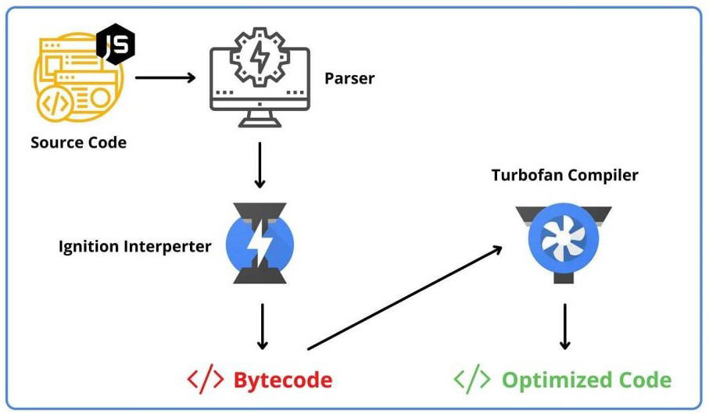
JavaScript has no compilation step. Instead, an interpreter in the browser reads over the JavaScript code, interprets each line, and runs it. More modern browsers use a technology known as Just-In-Time (JIT) compilation, which compiles JavaScript to executable bytecode just as it is about to run.

Fig 4.4 Just-In-Time (JIT) compiler
Javascript is Interactive
JavaScript's interactive nature revolutionizes web development by infusing static web pages with dynamic behavior. With JavaScript, developers can seamlessly respond to user actions, such as clicks, mouse movements, and keystrokes, enabling the creation of engaging and responsive web experiences. Through the manipulation of HTML elements and CSS styles.
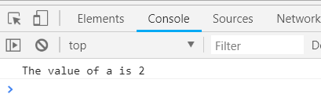

Fig 4.5 Javascript console

AI POWERED FITNESS APPLICATION 2025-26

Javascript is Object Oriented
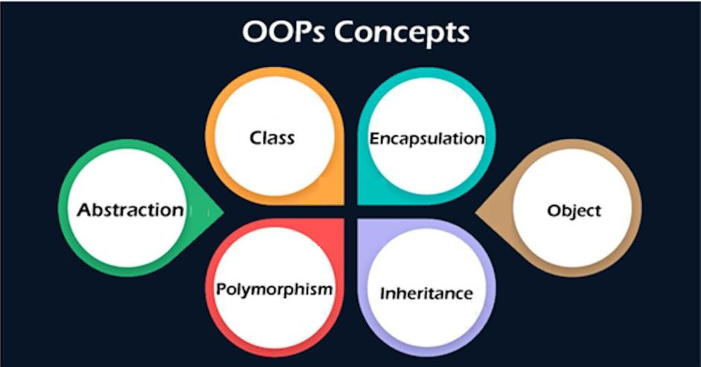
Javascript uses objects and follows the principles of OOP, but it does this using pure functions, which is a property of the functional programming paradigm (FP). JavaScript follows both OOP and FP and is actually a procedural language.

Fig 4.6 OOPs Concepts
Javascript Libraries
The JavaScript ecosystem is a vast collection of tools, frameworks, and libraries that are used for building web applications. It includes everything from development tools, front-end frameworks, back-end frameworks, libraries, package managers, and build automation tools.
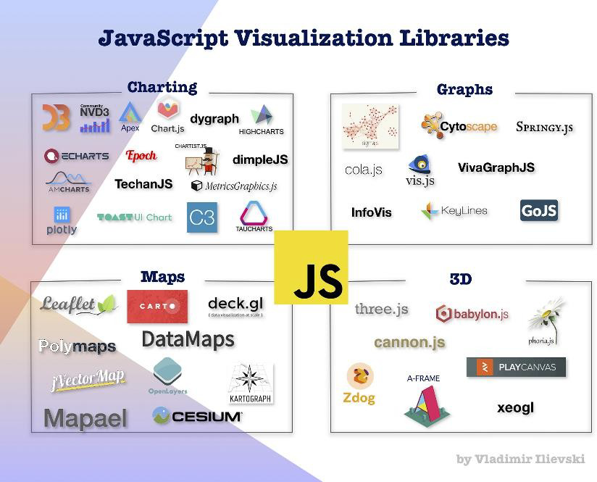

Fig 4.7 Javacript Libraries

AI POWERED FITNESS APPLICATION 2025-26

CHAPTER–5
SYSTEM DESIGN

Overview
Health Atlas is a web application designed to provide real-time feedback on exercise posture and technique, personalized workout and diet plans, and augmented reality visualizations. The system architecture incorporates frontend, backend, database, AR and computer vision modules, and deployment strategies to ensure a seamless and effective user experience.

5.1 Architecture Components

Frontend (Client-Side)
React.js: For building the user interface and ensuring responsiveness.
Typeacript : For managing the application CSS: Styling the ui interface

Backend (Server-Side)
Node.js: For server-side scripting.
Express.js: For creating RESTful APIs to communicate with the frontend.
Suerbase Authentication: For secure user authentication.

Database
Superbase (postreSQL): For real-time data storage and management, handling user profiles, workout data, diet plans, and progress tracking.
Computer Vision and Machine Learning

Mediapipe: For implementing real-time posture and technique analysis using machine learning

models

Deployment versel : For deploying the frontend application, ensuring fast and reliable acce

AI POWERED FITNESS APPLICATION 2025-26

Working of the Application
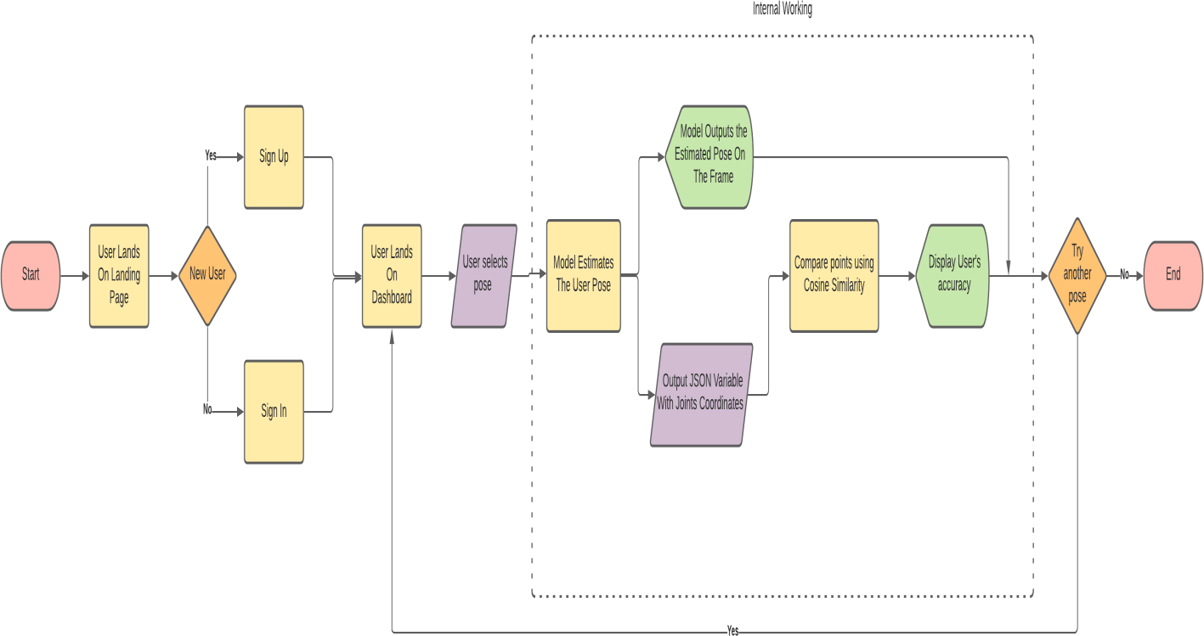

Fig 5.1 Working of the application

5.2 DATA FLOW DIAGRAMS (DFD)/ FLOW CHARTS
The DFD is also called as bubble chart. It is a simple graphical formalism that can be used to represent a system in terms of input data to the system, various processing carried out on this data, and the output data is generated by this system.
The data flow diagram (DFD) is one of the most important modeling tools. It is used to model the system components. These components are the system process, the data used by the process, an external entity that interacts with the system and the information flows in the system.
DFD shows how the information moves through the system and how it is modified by a series of transformations. It is a graphical technique that depicts information flow and the transformations that are applied as data moves from input to output.
DFD is also known as bubble chart. A DFD may be used to represent a system at any level of
abstraction. DFD may be partitioned into levels that represent increasing information flow and
functional detail.

AI POWERED FITNESS APPLICATION 2025-26

5.3 CLASS DIAGRAMS
In software engineering, a class diagram in the Unified Modeling Language (UML) is a type of static structure diagram that describes the structure of a system by showing the system's classes, their attributes, operations (or methods), and the relationships among the classes. It explains which class contains information

USER
LIVEVIDEO
LoadDataset()
ViewResult()

SYSTEM
LIVEDETECTION
ReadPosture()
ViewInstructions
Analysis ofPerfomance

Fig 5.5 CLASS DIAGRAM

User Authentication and Profile Management Authenticate User
Manage User Profile
Exercise Tracking and Feedback

Capture Exercise Data Analyze Posture and Technique Provide Feedback
Personalized Workout Plans

Generate Workout Plan Adapt Plan Based on Progress Diet Recommendation

AI POWERED FITNESS APPLICATION 2025-26

5.4 SEQUENCE DIAGRAMS

A sequence diagram in Unified Modeling Language (UML) is a kind of interaction diagram that shows how processes operate with one another and in what order. It is a construct of a Message Sequence Chart. Sequence diagrams are sometimes called event diagrams, event scenarios, and timing diagrams.
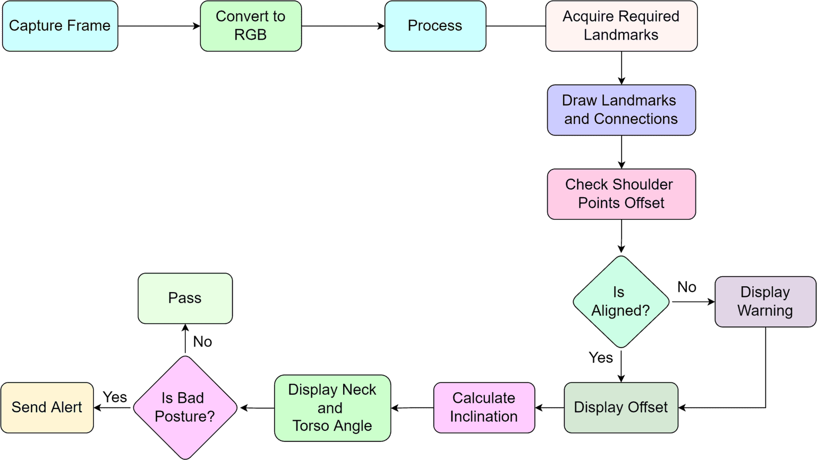

Fig 5.6 Sequence Diagram

AI POWERED FITNESS APPLICATION 2025-26

USE CASE DIAGRAMS

A use case diagram in the Unified Modeling Language (UML) is a type of behavioral diagram defined by and created from a Use-case analysis. Its purpose is to present a graphical overview of the functionality provided by a system in terms of actors, their goals (represented as use cases), and any dependencies between those use cases. The main purpose of a use case diagram is to show what system functions are performed for which actor. Roles of the actors in the system can be depicted.

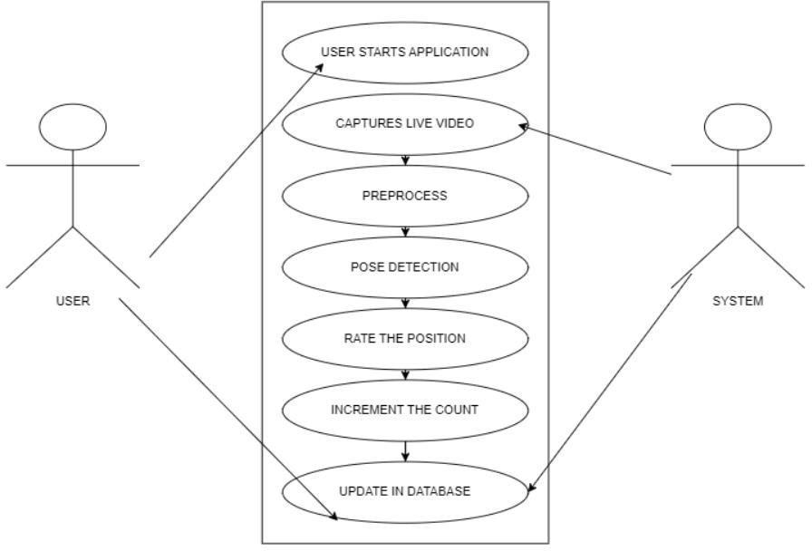

Fig 5.7 USE CASE DIAGRAM

AI POWERED FITNESS APPLICATION 2025-26

CHAPTER - 6
MODULES AND IMPLEMENTATION
We are planning to implement this project using the following modules:

Modules:
User Authentication and Profile Management Exercise Tracking and Feedback Personalized Workout Plans
Diet Recommendations Progress Tracking

6.2 Module Descriptions:
User Authentication and Profile Management:
The system uses Firebase for secure user authentication, enabling users to sign up, log in, and recover their passwords. User profile data, including fitness goals and dietary preferences, are stored and managed within Firebase.
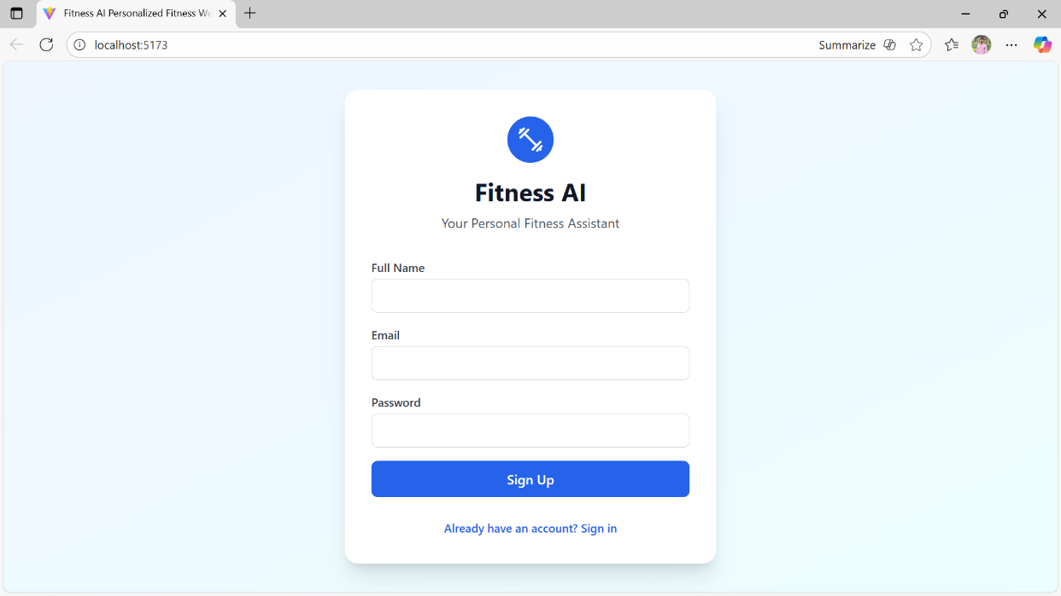

Fig 7.1 User Authentication
AI POWERED FITNESS APPLICATION 2025-26
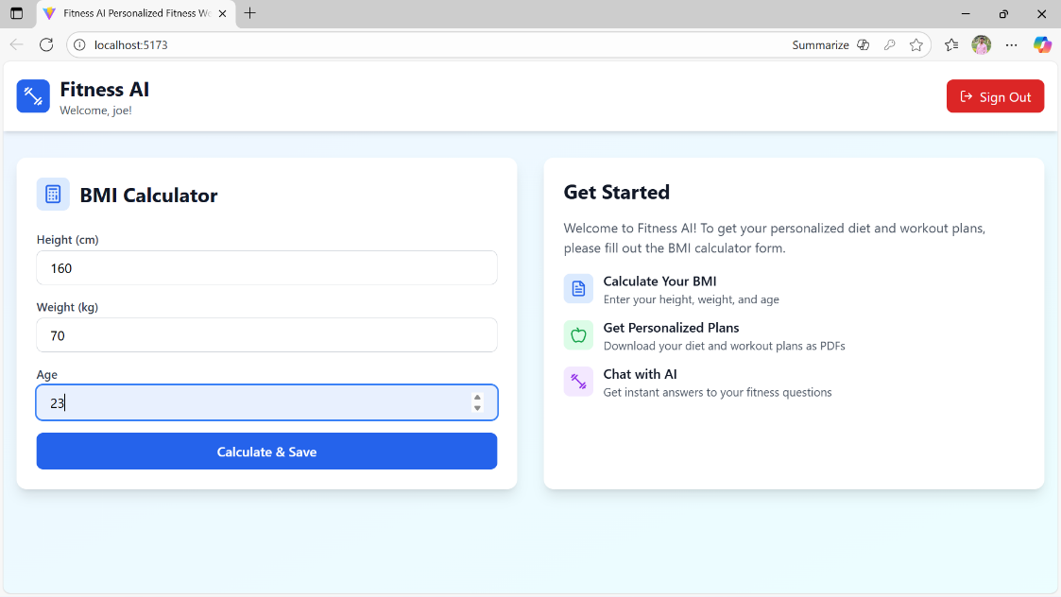

Fig 7.2 Profile Management

Exercise Tracking and Feedback:
Health Atlas employs augmented reality (AR) and pose estimation techniques using Mediapipe to track and analyze user exercises in real-time. The system provides visual and textual feedback to guide users in maintaining correct posture and technique, reducing the risk of injury.
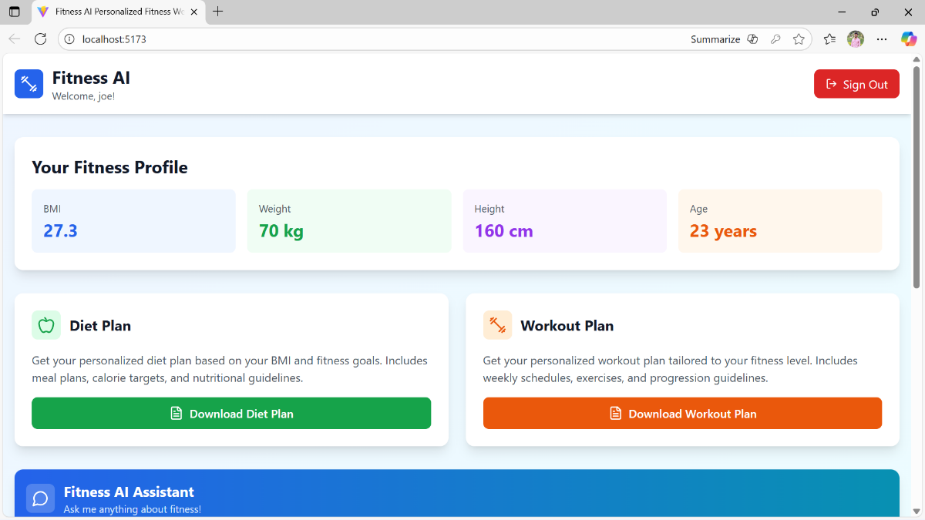
Fig 7.3 Tracking

AI POWERED FITNESS APPLICATION 2025-26

Diet Recommendations:
The app collects user dietary preferences and fitness goals to provide personalized diet plans. It uses external APIs like Nutritionix to fetch nutritional information and generate tailored dietary recommendations, promoting healthy eating habits.
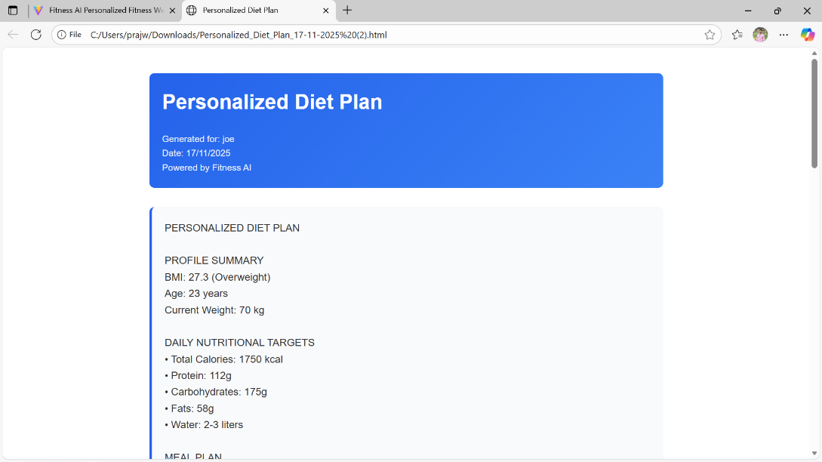

Fig 7.4 Diet Plan

Ai Assistance:
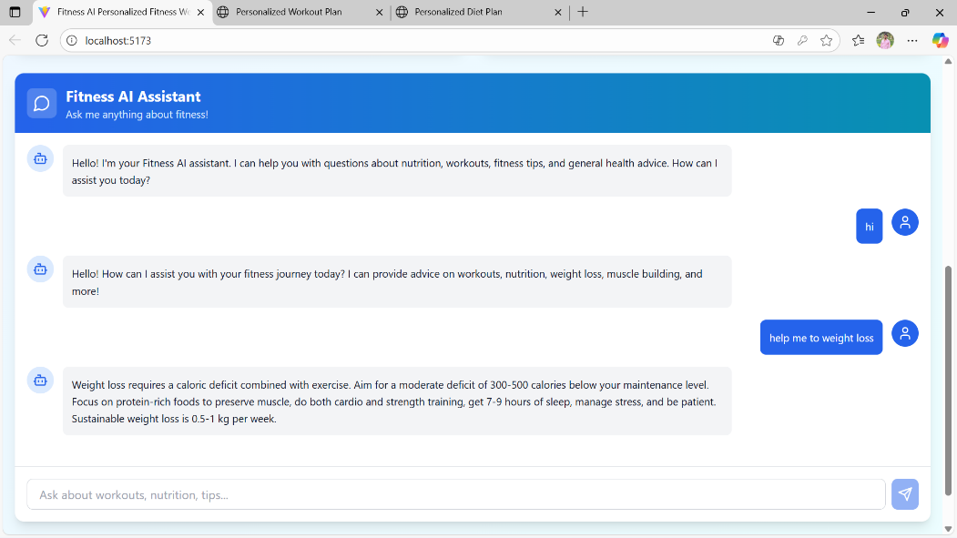
Health Atlas tracks user performance data and workout history to monitor progress. The system generates visual reports and achievements to motivate users and help them stay on track with their fitness goals.

Fig 7.5 Ai chatbot
AI POWERED FITNESS APPLICATION 2025-26

Methodology:

The AR feature uses the device camera to capture real-time images of the user performing exercises. These images are processed to detect body poses and provide feedback on exercise.

Training Phase:
During the initial phase, users are guided through a series of exercises to calibrate the system to their specific body measurements and movements. This data is used to improve the accuracy of the pose estimation and feedback mechanisms.

Exercise Recognition:
The system employs pose estimation techniques using Mediapipe to recognize and analyze different exercises. By identifying key body landmarks, the system evaluates the user's form and provides corrective feedback.

Experimental Setup:
The application is deployed on Netlify for easy access and uses Firebase for backend services such as authentication and data storage. The frontend is built using React.js, incorporating Material UI for a responsive and user-friendly interface.

MediaPipe Architecture
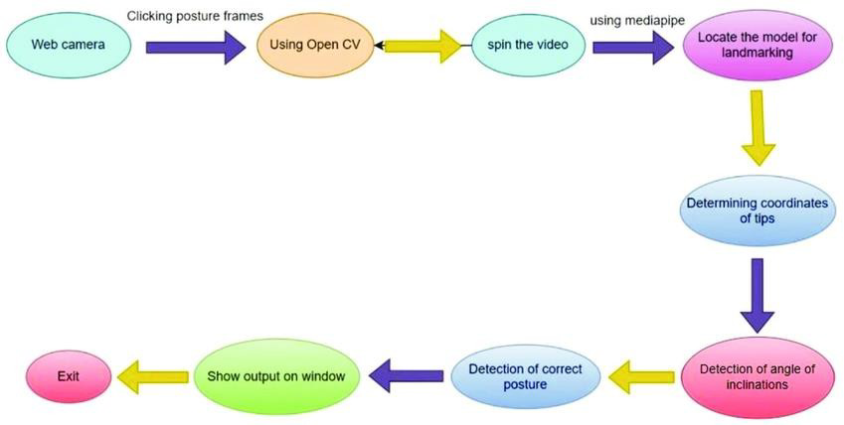

Fig 7.6 Media Pipe Architecture
AI POWERED FITNESS APPLICATION 2025-26

CHAPTER – 7
CONCLUSION

Health Atlas is an innovative web application designed to enhance users' health and fitness journeys by leveraging modern technologies such as augmented reality, machine learning, and cloud services. By providing real-time feedback on exercise posture and technique, Health Atlas helps users maintain correct form, thereby reducing the risk of injury and improving workout effectiveness.

The application offers personalized workout plans tailored to individual fitness goals, body types, and progress metrics. These plans are dynamically adapted based on continuous user feedback and performance data, ensuring a highly customized fitness experience. Furthermore, Health Atlas provides personalized diet recommendations based on users' dietary preferences and fitness objectives, promoting healthy eating habits that align with their workout routines.

Health Atlas's architecture is robust and scalable, utilizing React.js for the front-end, Firebase for authentication and data management, and Netlify for deployment. The integration of the Mediapipe library for real-time pose estimation and feedback adds a sophisticated layer of functionality that sets Health Atlas apart from traditional fitness apps.

By deploying Health Atlas on Netlify, the application ensures fast, reliable, and scalable access for users. The seamless integration with Firebase provides secure and efficient user authentication and data storage, enhancing the overall user experience.

The comprehensive feature set, including real-time AR feedback, personalized workout and diet plans, and progress tracking, makes Health Atlas a valuable tool for anyone looking to improve their health and fitness. The application's ability to provide immediate feedback and tailored recommendations empowers users to achieve their fitness goals more effectively and safely.

AI POWERED FITNESS APPLICATION 2025-26

7.2 Future Enhancements
Health Atlas aims to continuously evolve by incorporating new features and improvements. Here are some potential future enhancements:

Integration with Wearable Devices
Integrate Health Atlas with popular wearable fitness devices (like Fitbit, Apple Watch, and Garmin) to provide more comprehensive tracking and analysis of users' physical activities, heart rates, and sleep patterns.

Advanced AI and Machine Learning
Leverage advanced AI and machine learning algorithms to provide even more accurate posture correction and personalized recommendations. This could include predictive analytics to anticipate user needs and suggest proactive measures.

Expanded Exercise Library
Continuously update and expand the exercise library to include more diverse workouts and variations. This would cater to users of all fitness levels and preferences, ensuring that everyone finds workouts suited to their needs.

Social Features and Community Engagement
Introduce social features that allow users to share their progress, join fitness challenges, and connect with friends or community members. This could foster a sense of community and motivate users through social interaction and support.

Virtual Coaching and Live Sessions
Add options for virtual coaching sessions and live workout classes, providing users with real- time guidance and motivation from professional trainers. This can enhance the user experience by offering a more interactive and engaging fitness journey.

AI POWERED FITNESS APPLICATION 2025-26

Gamification
Incorporate gamification elements like badges, rewards, and leaderboards to make the fitness journey more fun and engaging. Users could earn rewards for reaching milestones, completing challenges, and maintaining streaks, adding an element of competition and motivation.

Multilingual Support
Expand the application's accessibility by adding support for multiple languages, allowing non- English speaking users to benefit from the app's features and content.

Mental Health and Wellness Features
Introduce features focused on mental health and overall wellness, such as guided meditation sessions, stress management techniques, and mental health tracking. This would provide a holistic approach to health and fitness.

Offline Mode
Develop an offline mode that allows users to access workout plans, track exercises, and log meals without needing an active internet connection. This can be particularly beneficial for users in areas with unreliable internet access.
Summary:
Health Atlas is an AI-powered fitness web application that enhances home workouts through real-time posture feedback, personalized workout and diet plans, and an engaging user experience. Built on a scalable and secure architecture using React.js, Firebase, Mediapipe, and Netlify, the application ensures effective, safe, and customized fitness guidance. Future enhancements aim to expand functionality through wearable integration, advanced AI, social and gamified features, virtual coaching, multilingual support, mental wellness tools, and offline access, making Health Atlas a comprehensive and holistic fitness solution. .
AI POWERED FITNESS APPLICATION 2025-26

REFERENCES

[1] Saiful Singar, Ravinder Nagpal, Bahram H. Arjmandi, and Neda S. Akhavan. Personalized Nutrition: Tailoring Dietary Recommendations through Genetic Insights (2024), e-ISSN: 2072-6643- www.mdpi.com.
[2] Sathya A, Vignesh A, Akash M, Gokulakrishnan S, Narendran M. Fit ness Guide: A Holistic Approach for Personalized Health and Wellness Recommendation System (2024), www.ieeexplore.ieee.org. Reporting System(2024) ISSN (Online) 2581-9429
[3] Asst Prof. Mrs. D. Navya Narayana Kumari, T. Praveen Satya, B. Manikanta, A. Phani Chandana, Y. L.S Aditya. Personalized Diet Rec ommendation System Using Machine Learning (2024), e-ISSN: 2278 0181- www.ijert.org.
[4] Akshay R Jain, Rudrang M. Darade, Akshay V. Dandwate, Shubham S. Joshi, Sahil S. Kothmire. Personalized Exercise and Diet Plan Recom mendation System for Gym (2024), e-ISSN: 2349-5162 www.jetir.org.
[5] Konstantin R. Strömel, Stanislas Henry, Tim Johansson, Jasmin Niess, Paweł W. Wo´zniak. Narrating Fitness: Leveraging Large Language Mod els for Reflective Fitness Tracker Data Interpretation (2024), Proceedings of the CHI Conference on Human Factors in Computing Systems (CHI ’24).
[6] B. Kumar, V., et al., “AI-Driven Fitness Coach: Webcam-based Form Correction and Rep Counting for Optimized Workouts,” IEEE, 2024.
[7] A. Sinha, et al., “A Comprehensive Study of a Conversational AI Driven Healthcare Bot with Pose Estimation for Precision Fitness Monitoring and Personalized Guidance,” IEEE, 2024.
[8] Y. M. Yee, et al., “FitBot: A ChatGPT Mobile Application-Based Fitness Tracker for Elderly Users,” IEEE, 2024.
[9] M. Gandhi, et al., “IntelliDoctor – AI-based Medical Assistant,” IEEE, 2019.

